Entity-relationship model

Introduction
At the end of this Chapter, the learner will be able to:
- Learn how to convert functional needs to a conceptual data model
- Identify the main concepts of the Entity-relationship model

Entity

Entity / Relationship model

- The Entity-relationship model is a type of conceptual diagram widely used for databases data, including relational databases.
- It is a tool for describing the structure of a database by highlighting many concepts:
  - Entity
  - Relation
  - Cardinalities
  - Attributes / Identifier
  - etc.

Additional Resources
#Entity Relationship Diagram#Data Modeling#Data Modeling
http://www.agiledata.org/essays/dataModeling101.html
http://www.agiledata.org/essays/dataModeling101.html
https://www.youtube.com/watch?v=c0_9Y8QAstg&ab_channel=NorwalkAberdeen

Entity
- An entity is an abstract representation of a real world object.
- An entity represents a physical or logical object.
- The object which will be represented with an entity must have different characteristics.
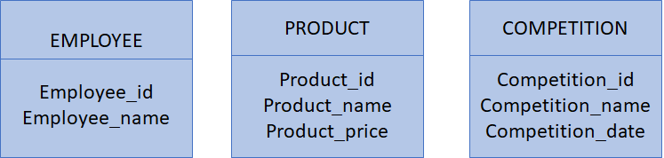

Additional Resources
#Entity Relationship Diagram#Data Modeling#Data Modeling

Attributes
- Each entity is described based on a list of properties which characterize the entity.
- At this level, the attributes are defined with their names (designation). It is not necessary to identify types of the different attributes
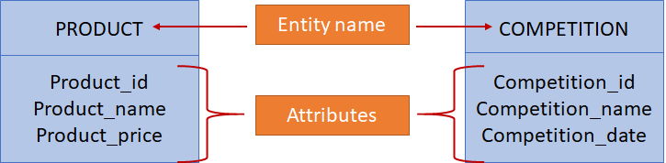

Additional Resources
#Entity Relationship Diagram#Data Modeling#Data Modeling

Entity Identifier
- An entity identifier is a property (attribute) which can qualify an occurrence of an entity.
- The entity identifier can be simple or composed of multiple attributes.
- An entity identifier is assigned to each entity upon creation.
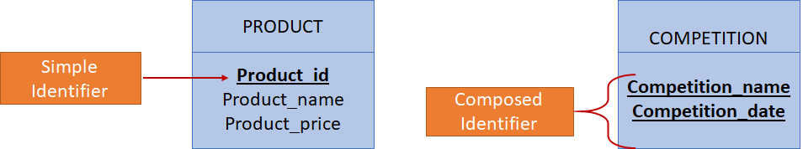

Additional Resources
#Entity Relationship Diagram#Data Modeling#Data Modeling

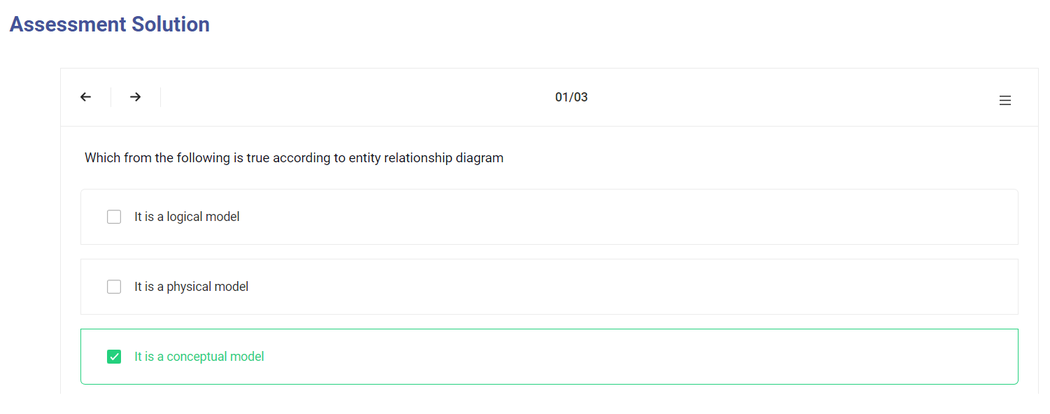
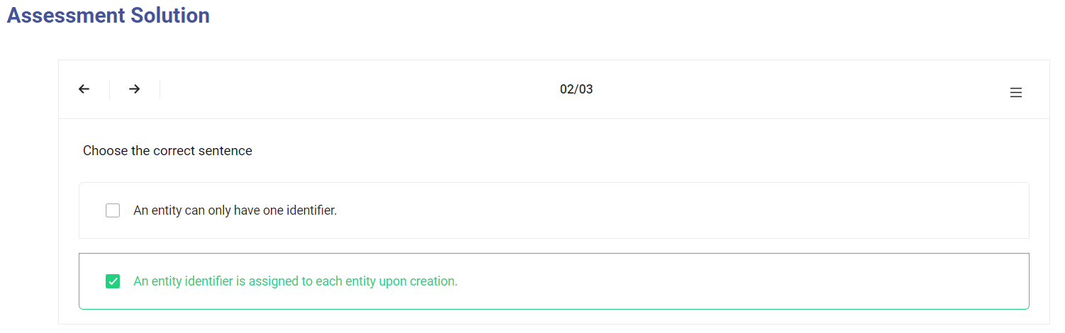
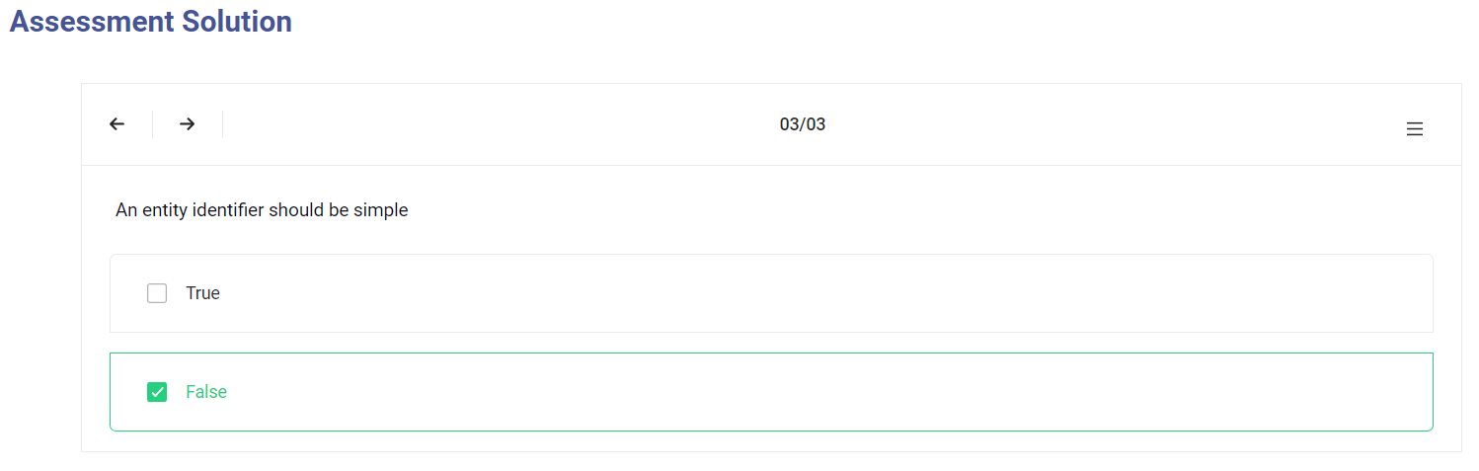

Relationship
- A relationship represents links between entity occurrences.
- Several employees works in the department “department_1”.
- The relationship models the relation or association between department and employee entities
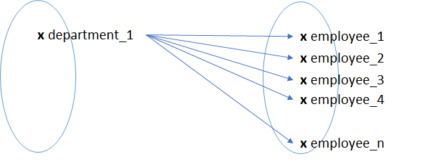

Additional Resources
#relationship
http://www.agiledata.org/essays/dataModeling101.html

Relationship
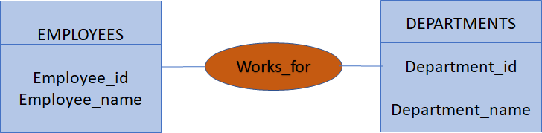
A relationship can have more information (attributes)
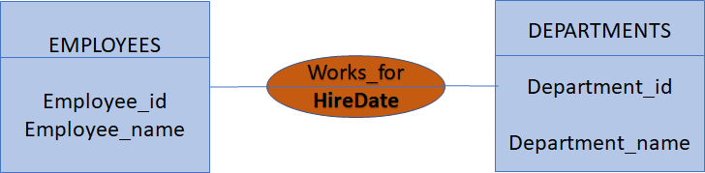

Additional Resources

Cardinalities
- Cardinalities are among the properties of an association.
- In DBMS, cardinality refers to the relationship between two entities. We should have two terms of cardinalities, on the side of each entity.
- It models the number of times (minimum-maximum) of participation of the entity in the relationship.
- The minimum value is either 0 or 1 and the maximum value varies between 1 and N

Additional Resources
#relationship

Cardinalities
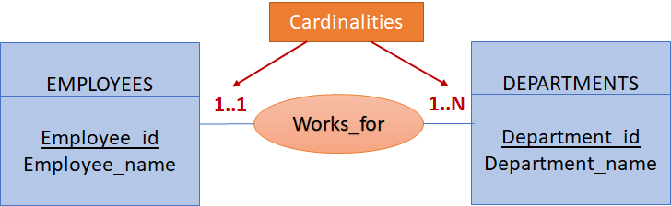
- One employee works in one department
- A department hires between one and N employees
- There are 4 types of cardinalities : 0..1, 0..N, 1..1, 1..N

Additional Resources
#relationship

Relationship types
- The type of a given relationship can be identified based on the cardinalities of each side.
- There are 3 types of relationship:
  - OnetoOne (1..1)
  - OnetoMany (1..N)
  - ManytoMany (N..N)
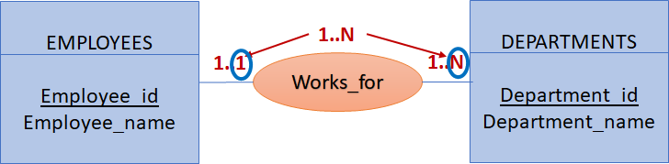
Works_for” is OnetoMany relationship.

Additional Resources
#relationship
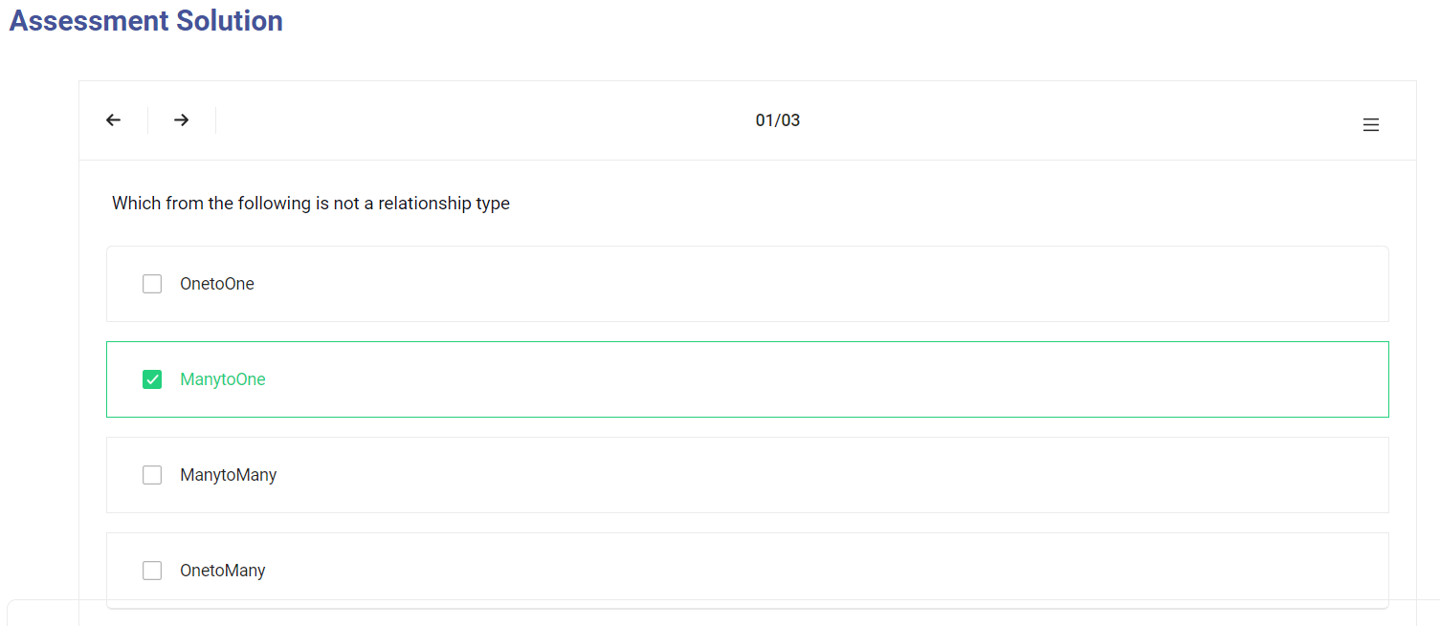
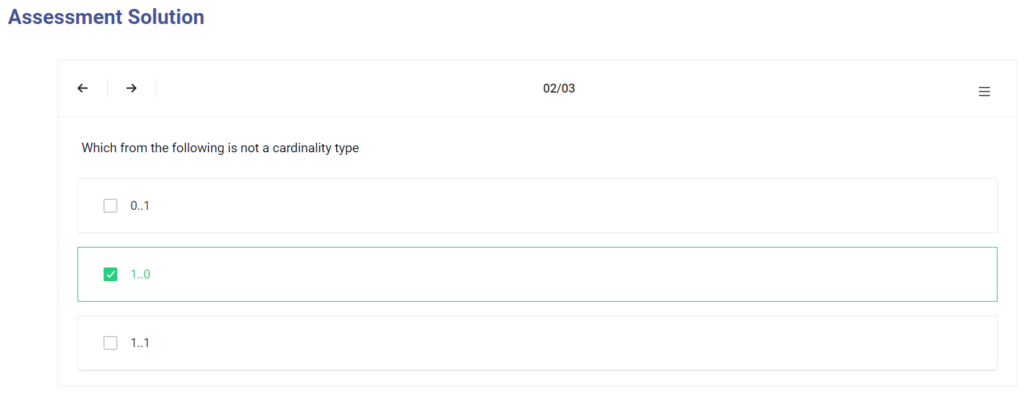
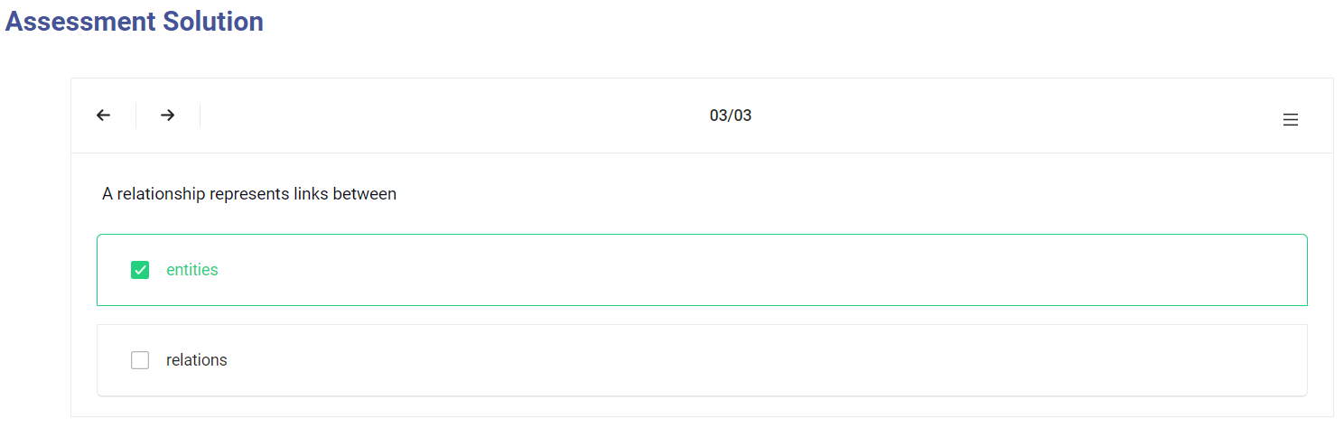

Other types of entities and relatioship

Sub-Entity
- A sub-entity expresses the notion of inheritance.
- Sub-entities inherit attributes from the parent class with some specifications which are those attributes.
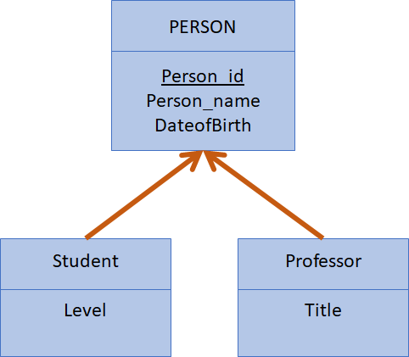

Additional Resources
#Data Modeling
http://www.agiledata.org/essays/dataModeling101.html

Weak entity
- An entity that cannot be uniquely identified by its own attributes and relies on the relationship with other entity is called weak entity.
- A weak entity is an entity without identifier which depends on another so-called strong entity.
- The weak entity is represented by a double rectangle.
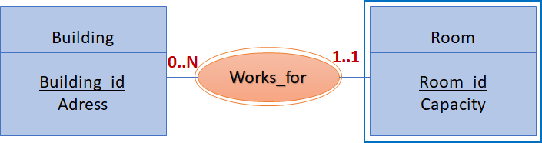

Additional Resources
#Data Modeling

Reflexive relation
A reflexive association is a binary association which involves the same entity twice.
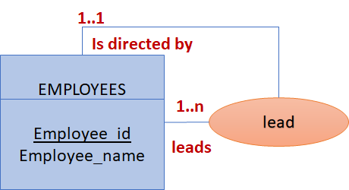

Additional Resources
#Data Modeling

n-ary relationship
- In an n - ary relationship, the n shows the number of entities in the relationship.
- If n=1, we get a reflexive relation, if n=2, it is a binary relation which links between 2 entities.
- if n>2, we talk about n-ary relationship, which involves three or more entities.
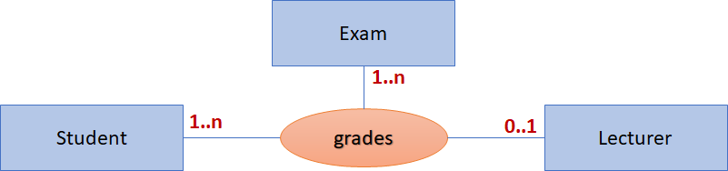

Additional Resources
#Data Modeling
